Andrew Sprowle, 1710-1776: “Lord of Gosport”
John G. M. Sharp
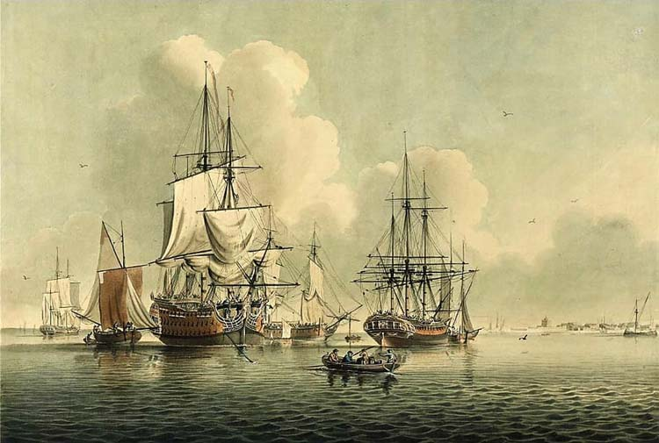
Introduction: Andrew Sprowle (1710-1776) in his time was a British naval agent, a Loyalist, a wealthy merchant, ship and shipyard owner, and a slaveholder. To his contemporaries, he was “a merchant of great reputation,” “large landowner,” one of the “richest men in the country,” “the headman of Portsmouth,” and “Lord of Gosport.”¹ During his long life “he was the most influential resident of the Norfolk region…”² Today Andrew Sprowle is best remembered for establishing the Gosport Shipyard, now the Norfolk Naval Shipyard.
1 Kranish, Michael, Flight from Monticello: Thomas Jefferson at War, 2011, (New York Oxford University Press, 2010), p. 69.
2 Kranish, Ibid.
This paper examines the life of Andrew Sprowle, a Scottish immigrant who made a swift ascent to vast wealth and power in colonial Virginia. Sprowle’s business savvy and energy both dazzled and aggravated his contemporaries. However, in a dramatic reversal of fortune in the last year of his life, Andrew Sprowle and his family became refugees. In 1775 the Sprowles fled their home along with hundreds of fellow Loyalists and were forced to seek shelter with Lord Dunmore's fleet. There, a helpless and frail Sprowle could only watch as his homes, businesses, and commercial empire were destroyed and consumed by fire.³
3 Gara, Donald J. “Loyal Subjects of the Crown: The Queens Own Loyal Virginia Regiment and Dunmore’s Ethiopian Regiment, 1775-1776” Journal of the Society for Army Historical Research, vol. 83, no. 333, 2005, pp. 30–42. JSTOR, www.jstor.org/stable/44231142, accessed 8 July 2021.
Sources: Modern historians examining Andrew Sprowle and his family are frequently left with large gaps in their narrative. The reason is Sprowle’s personal and business correspondence was (were) destroyed during the early years of the American Revolution. In the hope of filling in a few of the blanks spaces, I have relied extensively on primary source documents found in American Loyalist Claims, 1776-1835. These volumes contain evidence of claims, witness statements, petitions and testimony in support of loss claims filed by Andrew Sprowle’s widow, Katherine Hunter Sprowle, his nephew John Hunter, Jr., and his business agent Thomas McCulloch.
Andrew Sprowle’s last will dated 12 January 1774 is central to our knowledge for it brings together a great deal of valuable information related to his family, his business affairs and his overall perspective. Scholars wanting to learn more about Sprowle’s business ventures owe a debt of gratitude to Jacob M. Price, author of “The Last Phase of the Virginia-London Consignment Trade: James Buchanan and Co., 1758-1768.” Price found Sprowle did a considerable business with firms in both London and Glasgow and was able to locate and analyze the accounts of the London commission house of Buchanan and Co. Price’s analysis provides our best indication we have (dele) of just how extensive and lucrative Sprowle’s business had become.
Extremely useful for the official views and perspectives of both sides of the American Revolution are the 13 volumes of Naval Documents of the American Revolution, American Theatre. Documentation for Andrew Sprowle and events in Norfolk are found in volumes 4 and 5, editor William James Morgan, (Government Printing Office, Washington, D.C., 1970). These are now online at Naval History and Heritage Command
https://www.history.navy.mil/research/publications/publications-by-subject/naval-documents-of-the-american-revolution.html
These naval(dele) documents contain diaries, letters, petitions and ships' logs,(dele) as well as muster rolls, orders, official reports and newspaper accounts. The collection includes American, British, French and Spanish points of view and gives voice to common seamen, civilians, women and slaves,(dele) as well as policy makers, political leaders and naval and military officers.
There is direct evidence for Andrew Sprowle’s participation in the Intra-American slave trade. To my knowledge,(stet) no previous mention has been made of Sprowle and the firm Sprowle & Crooks, whose ownership of (dele) vessels which(dele) delivered enslaved human cargo from the Caribbean to Virginia. His 1774 will and subsequent claims filed by his widow Katherine make it clear he was a prosperous slaveholder. However, it was not until I read Elizabeth Donnon’s extensive 1935, (dele) Documents Illustrative of the Slave Trade to America, that I found actual citations that Andrew Sproule, aka Sprowle, was indeed a slave ship owner. Recently,(stet) much of this important information has been utilized on the website Slave Voyages, hosted by Rice and Emory Universities at https://www.slavevoyages.org/american/database#results
I found the best introduction to Andrew Sprowle’s family and a window into his early life in Scotland while reading James Spreull’s (How is this person’s name spelled – see the next para) wonderful Eight Centuries of the Spreull and Sproule Families (Why is this not all italicized??). Previously I imagined Andrew as a working class immigrant. My thanks to Mr. Spreull for a brilliant book and for setting me right.
Lastly, a few words about the(stet) Sprowle family surname. As James Sproule reminds us, during Andrew Sprowle’s lifetime, his family surname was spelled variously, sometimes even in the same document. Among the different spellings were, Sproule, Spreulle, Sproul, Sproull, and Sprowle. For example, Andrew’s father, John, spelled his name Spreull while Andrew spelled it Spreule and Sprowle. For the sake of consistency, I have chosen to spell the family surname as Sprowle, which is how Andrew signed his will on 12 January 1774.⁴
4 1779 Sprowle Andrew, (Wills and testaments Reference CC8/8/124, Edinburgh Commissary Court) Image 1051-1062, National Records of Scotland “Andrew Sprowle formerly of Milton in North Britain but late of Gosport in the County of Norfolk and Colony of Virginia” Signed 12 February 1774
John G. M. Sharp, 19 July 2021 – I don’t know why this is here
Early Years in Scotland: Much of our biographical information on Andrew Sprowle is by way of his widow(stet), Katherine Hunter Sprowle. Katherine, Andrew’s widow,(dele) testified in 1783,(dele) that he was born in Scotland,(dele) and that she had heard him say,(stet) “[he] went to America when he was 15 years of age; he was 65 years of age when he died in 1776. (This must have been in the year 1726.) (This previous sentence makes no sense as it stands. Does this refer to the year he said he went to America? If so, state that.)”⁵ Andrew’s will,(stet) dated 12 January 1774,(stet) confirmed his place of birth as Milton, aka Miltoun, in Dunbartonshire, Scotland. Milton was and is a small village located almost 5 miles from Glasgow.⁶ Genealogist and researcher James Spreull, in his,(dele) Eight Centuries of the Spreull and Sproule Families,(stet) found the Spreull (Sprowle) family had at least seven children. Andrew, who was born in 1710, was the third son of John Spreull I, (1665-1731), Laird of Milton.⁷
5 American Loyalist Claims, 1776-1835. AO 12–13, Katherine Sproule, aka Katherine Sprowle, AO13: American Loyalist Claims, Series, II, Piece ,033 B.T.W. and Miscellaneous Virginia, p. 144, hereafter Loyalist Claims, Katherine Sprowle The claim is dated 18 October 1783.
Also see Virginian-Pilot, Flanders, Alan, 11 January 1998, "Shipyard Founder's Identity Hidden by Mist of Time”
6 1779 Sprowle, will, Ibid, “Andrew Sprowle formerly of Milton in North Britain but late of Gosport in the County of Norfolk and Colony of Virginia.”
7 Sproule, James Richard, Eight Centuries of the Spreull and Sproule Families, (Create Space London, Independent Publishing, 2017) p. 202.
Scotland in the eighteen century was a strongly patriarchal society in which men had total authority over women,(stet) but how it actually worked in practice remains a subject of debate among historians. Evidence of this patriarchal tradition is found in the baptismal certificates of old parish registers, where the mother's names in parts of eighteenth century Scotland are frequently excluded. Hence at Andrew’s baptism, the name of his mother (despite James Spreull’s best efforts) is still unknown.
In Scotland both law and custom, dictated primogeniture and(stet) governed inheritance. Thus John Spreull,’s firstborn son, John Spreull II, (1700 -1771), inherited both the family land and the title. How close Andrew was to his older brother is difficult to gauge,(stet) but Andrew’s 1778 will reflects that(stet) his younger sister Jane Spruill (1704 to after 1776) remained close to him.⁸
8 Ibid, p..203.
In Scotland,(stet) the title Laird (English – Lord) is a generic name for the owner of a large, long-established Scottish estate. In the Scottish order of precedence, a Laird ranks below a baron and above a gentleman.⁹ Andrew’s father, John Spreull I, held a variety of important government posts such as Commissioner of Supply for Ayrshire and Dumbarton. As Commissioner of Supply, he ensured the collection and recording of "cess" or land tax to supply the financial needs of the sovereign. Land tax rolls were compiled by the Commissioners of Supply in each county to enable the collection of the land tax from 1667 onwards. The duties included listing the owners of landed estates and assessing the rental value of their lands. From 1718,(stet) the Commissioners of Supply became responsible, along with justices of the peace, for county roads and bridges;(stet) in many cases,(stet) the commissioners appointed special constables for all or parts of their counties.¹⁰ During the serious Jacobite revolts in 1715 and 1719 which plagued Scotland, Andrew’s father managed to stay above the political fray; he remained loyal to the English crown and continued in office.
9 Innes of Learney, T., Scots Heraldry (2nd ed.), (Edinburgh, R. & R. Clark Limited, 1956).
10 Highway (Scotland) Act 1718 (1718 c. 30) and Representation of the People (Scotland) Act 1832 (1832 c. 65, section 44).
Consequently John Spreull I, as a Laird and Commissioner of Supply, was a man of considerable importance,(stet) having both family and friends involved in a wide circle of commercial ventures in Glasgow and Edinburgh. As both Laird and Commissioner,(stet) John Spreull I controlled certain appointments and could dispense favors using state resources. Likewise, John I would expect political and social deference in return. Andrew’s older brother John Spreull II was educated at Glasgow University. Andrew, however, was most likely educated in a local parish school. While we know little of Andrew Sprowle’s youth, what evidence we have suggests he possessed enormous ambition. Given his family’s close proximity to Glasgow, it is likely that Andrew spent a lot of time in that city which by 1720 was the second largest city in Scotland with a population of(stet) 15,000. By comparison,(stet) the population of New York City did not reach 12,000 until 1750 and Norfolk, Virginia, would only reach 6,250 in 1775. Writer Daniel Defoe in 1726 described Glasgow as "The cleanest and best-built city in Britain"; 50 ships a year sail to America(What is this? – part of the quote??). His keen mind would have observed the benefits to Glasgow from the transatlantic tobacco trade and supplying the colonies with manufactured goods. He also would have seen that merchants dealing in this lucrative business became wealthy and dominated the city. Andrew’s determination to enter business likely developed while(stet) clerking for his father or with his father’s business associates in their firms situated near the great harbor and the Clyde River (or River Clyde??). We may imagine that it was in Glasgow that Andrew initially absorbed the techniques of commercial shipping, recording keeping, commercial statements credit and loss and most importantly being seen in the new shipyards which would build the vessels that transformed Scottish business and industry.¹¹
11 J. D. Mackie, B. Lenman and G. Parker, A History of Scotland (London: Penguin, 1991), p. 296.
While we can discern nothing of Andrew’s physical appearance, we know he had a portrait made prior to 1774 and that he wanted it preserved and took great pains in his will to “recommend my picture being sent home to my sister [Jane Sprowle]. She orders the delivery of it and on her death to those relations of mine that will take great care of it.”^{12, 13}
12 Virginia Pilot, Flanders, Alan, 4 February 1996, A Walk in the Shipyard Founders' Footsteps, p. 11.
13 1779, Sprowle will, Ibid p. 1060,“I recommend my picture being sent home to my sister. She orders the delivery of it and at her death to those relations of mine that will take good care of it.”
Similarly Andrew’s 1774 will provides some clues as to his personality. Evident in the will is his keen sense of control; his business acumen, forethought and competitiveness all are on full display. In one paragraph he carefully instructs his heirs and executor that, “his houses and lands in Portsmouth shall be disposed of but not too suddenly as times are hard but when my Exec[utor] will find it most advantagous taking bonds with security for the money arising thereof.”¹⁴
14 1779 Sprowle, will, Ibid, p. 1056.
In another paragraph we see timing and prudence for Andrew are essential in all business transactions, even beyond the grave. He directs his executor, “… my plantation at Sewells Point be disposed of, but not too soon with the Negros or without. I also order my wares, goods and merchandise now at Gosport be disposed of but not too soon from the hardness of the times.”¹⁵
15 1779 Sprowle, will, Ibid p. 1057.
Virginia: Like many Scots who were the younger son of a minor Laird, Sprowle was drawn to business.¹⁶ If his wife Katherine’s recollection is accurate, then Andrew first came to Virginia circa 1725. However, I believe it is far more likely he came following the death of his father in 1731, perhaps after the reading of the will with both money and assistance from the estate. While we do not know his exact circumstance, we can safely surmise he was not without resources. His father John and older brother’s business connections would have been valuable assets.
16 Price, Jacob M. “The Last Phase of the Virginia-London Consignment Trade: James Buchanan and Co., 1758-1768.” The William and Mary Quarterly, vol. 43, no. 1, 1986, p. 89, JSTOR, www.jstor.org/stable/1919357, accessed 9 July 2021.
According to Norfolk County Court records, Sprowle was listed as a merchant of Norfolk Borough in 1746, and in 1752 purchased Portsmouth lots (numbers 11, 12 and 24) from William Crawford, acquiring other town lots and extending his holdings within a few years across Crab Creek with several waterfront tracts in Gosport, including part of the site of what later became the Gosport Navy Yard, and he was still buying Gosport property as late as 1772.¹⁷ Sprowle's prominence as shipbuilder and merchant was such that he served for 36 years as President of the Court of Virginia Merchants.¹⁸
17 Flanders, Alan, 11 January 1998, Ibid.
18 Loyalist Claims, Katherine Sprowle, Ibid.
His new Gosport shipyard quickly became a local wonder. The new yard included a large five-story warehouse which was then one of the largest buildings in North America. His shipyard was undoubtedly modeled on similar installations he saw as a young man on the banks of the River Clyde. His central warehouse was meant to be permanent. The massive structure was built with stone, 91 feet in length and 41 feet wide. Three of the stories were of stone and two of wood, the doors, windows and broad stairs hewn of stone mostly from Britain at great expense. The whole was of substantial materials and strong wood.”(Why this lonely quotation mark??) In addition, Sprowle's property “included three other warehouses, an accounting house, smith's shop, a dwelling house and kitchen”(stet) and a "large iron crane with brass sheaves,'' which was brought from London. ”(dele)^{19,} ²⁰
19 Virginian-Pilot, Flanders, Alan, 4 February 1996, A Walk in the Shipyard Founders Footsteps, p. 1, quoting Andrew Sprowle’s will.
20 1779 Sprowle, will, Ibid.
In May 1763,(stet) Portsmouth underwent its first annexation expanding the western boundary. The same year the governing body of town trustees was named, including Andrew Sprowle, George Veale, Thomas Veale, Charles Stuart, Humphrey Roberts, Francis Miller, James Rae, David Purcell and Amos Etheridge. ²¹
21 Butt, Marshall, Portsmouth under Four Flags, 1752-1970 (Portsmouth Historical Association & Friends of the Portsmouth Naval Shipyard Museum, Portsmouth, 1971), pp. 8–15.
The following is an extract from an Act passed in May 1763, eleven years after the institution of the town by which the first Board of Directors and Trustees were constituted and appointed,(dele) and their powers defined. That Andrew Sprowle, George Veal, Thomas Veal, Charles Steuart(different spelling from above), Humphrey Roberts, Francis Miller, James Rae, David Purcell, and Amos Etheridge, gentlemen, shall be, and they are hereby nominated, constituted, and appointed, directors and trustees of the said town; and they, or any five of them, shall and may, and they are hereby authorized and empowered to survey and lay off the said adjacent lands into lots and streets, and to make from time to time such orders, rules, and directions for the regular and orderly placing and building the houses.²²
22 Fowler, William S., Historical and Descriptive Sketches of Norfolk and Vicinity (Lindsay and Blakiston, Philadelphia,1853), p. 431.
In April 1765, an anonymous French traveler visited Sprowle’s home near Portsmouth Virginia. Where he recorded: “April the 19th, dined today with Andrew Sproul Esq., the head man of Portsmouth. He lives in a pleasant place separated by a creek from the town. His house goes by the name of Gosport. He has a very fine wharf, before his door, where the Kings ships generally heave down. This gentleman is a merchant of great repute.”²³
23 The American Historical Review, volume 26, p. 740. A French Traveler in the Colonies 1765.”https://archive.org/details/americanhistoric19201921jame/page/740/mode/2up
On April 24, 1765, the same French traveler “set out for Williamsburg with Andrew Sprowle, Esq., and several other Gentlemen.” The next day he recorded “In Williamsburg April the 25th on our arrival we had difficulty getting Lodging but thanks to Mr. Sprowle, I got a room at Mrs. Vaibes Tavern where all the best people reside.”²⁴
24 Ibid, pp 740-741.
In the eighteen century Scottish merchants exercised considerable control of the shipping and warehousing in the Chesapeake Bay area. Much of Andrew Sprowle’s wealth came from acting as a consignment broker for wealthy Virginia planters and merchants. One firm that he dealt with extensively was James Buchanan and Company of London whose transaction records for years 1758-1768 survive. Their records show that during this period, Sprowle’s business made up annually 30 to 60 % of everything James Buchanan owed Virginia. From these records we learn that in its best year, 1768, Buchanan and Company owed Sprowle £6,298.²⁵ £100 in 1765 is equivalent in purchasing power to £18,124.23 in 2021.²⁶
25 Price, Ibid, pp. 64-98.
26 Ian Webster, CPI Inflation Calculator, https://www.in2013dollars.com/uk/inflation/1765 accessed 17 July 2021
Slaveholder: From his first years in Virginia, Andrew Sprowle showed no qualms about enslaved labor and in fact such labor became integral to his shipyard and businesses. In the 1740’s,(stet) Sprowle entered the slave trade beginning with the charter of at least six privateers. Scholar Edward Frye found that,(stet) during this period,(stet) one of his(Sprowle’s) warehouses was a slave market.²⁷ Slave marketing seems to have been common in Norfolk during the late eighteenth century.²⁸ Slave traders like Sprowle were vital gears in the machine of slavery,(stet) often working with others in the community such as bankers, merchants and lawyers.
27 Frye, John, Hampton Roads and Four Centuries as a World Seaport, (The Edward Mellen Press, New York, 1996), p. 48.
28 Palladino, Brian David, "From a Determined Resolution to Get Liberty: Slaves and the British in Revolutionary Norfolk County, Virginia, 1775-1781" (2000), Dissertations, Theses, and Masters Projects, Paper 1539626267, p. 16. https://dx.doi.org/doi:10.21220/s2-4wyv-y677 accessed 18 July 2021.
There is no indication that Andrew Sprowle ever suffered socially for working in the slave trade. In fact, Methodist preacher Francis Asbury, who was in Norfolk in 1775, “singled him out as a prominent Methodist convert…” ^{29,} ³⁰ Unlike John Newton, 1725-1807, author of “Amazing Grace” and a former investor and captain of slave ships, there is no indication that Andrew Sprowle ever renounced the slave trade or had any sympathy for the enslaved.
29 Smith, George Gilman, Life and Labors of Francis Asbury, Bishop of the Methodist Church in America, (Barbee and Smith, Nashville, Tn..
30 Biography and the Black Atlantic, editors Lisa A. Lindsey, John Wood Sweet, (University of Pennsylvania Press, Philadelphia, 2013) p. 122, n 55.
Sometime in the 1740’s,(stet) Sprowle went into business with Robert Crooks and together they formed the commercial firm of Sprowle & Crooks. Their ships traded mostly in the southern coastal cities and in the Caribbean. Two of Sprowle’s vessels, the Saint Andrew and the sloop Providence, were involved in the Intra-American slave trade. Records from the years 1748 -1751 confirm Sprowle as the owner of both vessels. The documentation for Sprowle and the Intra-American slave trade(stet) relies heavily on that kept by British Naval Office officials. Most scholars believe these records are at best a glimpse of a larger enterprise now lost to time.³¹
31 Donnon, Elizabeth, Documents Illustrative of the Slave Trade to America, Volume IV, (Carnegie Institute, Washington D.C., 1935), pp 218-219, 221. https://archive.org/details/documentsillustr00donn_2/page/218/mode/2up?q=sprowl accessed 12 July
Sprowle’s ship captains, men like James Abercrombie, Thomas Langley and William Mclintock, transported enslaved men, women and children from(stet) Antigua and Barbados and then returned them(dele) to the Chesapeake area for delivery and sales.³² Sprowle and Crooks, like many of the Intra-American slave traders, did so as an adjunct to their other commercial and ordinary business. They apparently handled a wide range of household items too. For example, George Washington was familiar with the firm and in his diary entered that he observed Sprowle’s vessel, the Glasgow, on 18 October 1751.³³ George Washington made purchases from the same firm, as recorded in his ledger for November 1771 “Sprowle & Crooks, Estate for Candles, £ 3.00” ³⁴
32 Slave Voyages.org, Rice University, Emery University, Intra American Slave Trade, 1748-1751, Andrew Sprowle, owned three vessels, the ships, Saint Andrew , the Providence and the Glasgow https://www.slavevoyages.org/american/database accessed 11 July 11, 2021
33 “The Manuscript,” Founders Online, National Archives, https://founders.archives.gov/documents/Washington/01-01-02-0002-0005. [Original source: The Diaries of George Washington, vol. 1, 11 March 1748 to 3 November 1765, ed. Donald Jackson. Charlottesville: University Press of Virginia, 1976, pp. 34–37.] Sprowle & Crooks, a mercantile firm in Norfolk, was going out of business in the fall of 1771.
34 “Cash Accounts, November 1771,” Founders Online, National Archives, https://founders.archives.gov/documents/Washington/02-08-02-0357, [Original source: The Papers of George Washington, Colonial Series, vol. 8, 24 June 1767 to 25 December 1771, ed. W. W. Abbot and Dorothy Twohig. Charlottesville: University Press of Virginia, 1993, pp. 530-533]
What databases we have for the transatlantic trade voyages reflect the St. Andrew, Glasgow and the Providence in the 1740’s and 1750 made transatlantic voyages, some of these ships carried(stet) several hundred enslaved Africans from Africa,(dele) to the Caribbean. But for many of these years no names are provided for the vessel owner on the manifest.35
35 Slave Voyages Transatlantic Slave Trade Database, https://www.slavevoyages.org/
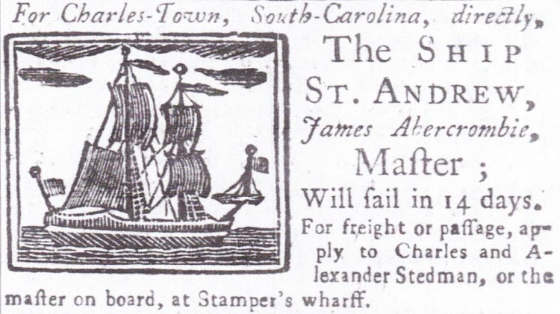
St Andrew, (Pennsylvania Gazette, Penn), 2 Nov 1749, p. 3.
Sprowle’s increased prosperity is reflected in the 1766 Portsmouth, Virginia, “List of Tithtables,” which enumerated Andrew Sprowle as a substantial landowner and slaveholder with at least twenty-three enslaved individuals.³⁶ In his will, signed 12 January 1774, Sprowle listed thirty-four enslaved individuals making him one of the largest slaveholders in the area,³⁷
36 Black Loyalist, University of Sidney Andrew Sproul aka Sprowle http://www.blackloyalist.info/person/display/765
37 Nicholls, Michael L., Aspects of the African American Experience in Eighteenth-Century Williamsburg and Norfolk, Colonial Williamsburg Foundation Library Research Report Series - 330 Colonial Williamsburg Foundation Library (Williamsburg, Virginia 1991). p.12.https://research.colonialwilliamsburg.org/DigitalLibrary/view/index.cfm?doc=ResearchReports%5CRR0330.xml
To John Hunter, Senior, the following negro slaves hereafter named unto him and the said John Hunter, Junior, and the heirs of his body lawfully begotten with these Negroes, Vizt Males, Portsmouth, Isaac, Joe, Lacy, Lavalt, Pero, Cuff, Nicholas, old Tom, Peter, Tango, Sam, young Tom, Daniel, Will and Sewells Point Sam and the following female slaves and their issue, Venus and her Children, Timothy Jonathan, Venus, Bett and her Grandchild Jacob, Frank and her Grandchild Sarah, Jeany and her son Lewis, Doneh and Children Sucky, Selvy, Big Judy, little Judy, Winney, Nell and Children Moll and little Selvy.
For comparison the 1774 “List of Tithtables” for Norfolk, Virginia, enumerated 758 white slaveholders, the vast majority of whom possessed less(fewer) than five enslaved individuals.
One of Sprowle’s enslaved workers took whatever opportunity they(he) had to flee bondage. An enslaved man named “Solomon” fled servitude in September 1768. In a notice published in the Virginia Gazette, Sprowle(stet) described him as “a Negro man named Solomon, the property of Andrew Sprowle of Gosport. He is a young fellow about 18 years of age, talks much, will pretend to be a free man, and a blacksmith”. Sprowle then notes that Solomon “served John Bell for some years.”³⁸ Sprowle offered a forty shilling reward. This notice suggests Sprowle rented young Solomon to John Bell on an annual basis. As early as May 1753, Sprowle’s need for labor at the shipyard was such that he rented additional enslaved laborers from other slaveholders.³⁹
38 Virginia Gazette (Williamsburg, Virginia), 22 September 1768, p. 3.
39 “Newton Family of Norfolk.” The Virginia Magazine of History and Biography, vol. 29, no. 4, 1921, pp. 516-519, JSTOR, www.jstor.org/stable/4243850, accessed 9 July 2021
This notice appeared on 1 January 1772:
RAN away on Thursday the 26th of December, a Negro fellow named Jack, about 26 years of age, 5 feet 6 or 7 inches high, and is a stout-made fellow, has a scar over his left eye, which may appear to a stranger blind, and another between his thumb and fore finger of the right hand. He carried with him, besides the usual clothing of laboring Negroes, a pair of buckskin breeches. The said fellow formerly belonged to Daniel Wolstenholme, Esq; of Maryland, and I bought him of Mr. Andrew Sprowle about two months ago. He is a very artful cunning fellow; and I do not doubt but will endeavor to make his escape towards Norfolk or to Maryland again. He was seen on the road to Williamsburg. I will give TWENTY SHILLINGS reward if taken up in the county, FIVE POUNDS if taken 50 miles from home, and TEN POUNDS if out of the colony, provided he is brought home. ROBERT WALKER.
Sprowle was called into court when his bondsmen were charged before a magistrate. On(stet) one occasion that(dele) his enslaved man “Instance” was prosecuted for "threatening to poison sundry slaves" and found guilty and punished by whipping. No doubt Sprowle was in attendance not to plead for mercy but to defend his property.⁴⁰ In the expanding economy Andrew Sprowle’s need for labor was such that he rented other enslaved individuals. In the American Revolution, the government of Virginia employed Sprowle slaves at public lead mines.⁴¹
40 Nicholls, Ibid p. 121.
41 Journal of the House of Delegates of the Commonwealth of Virginia ( Thomas W. White, Richmond, 1828), p.63 https://www.google.com/books/edition/Journal_of_the_House_of_Delegates_of_the/wEFFAQAAMAAJ?hl=en&gbpv=1&bsq=sprowle (see page 18).

STOP
Historian Michael L. Nicholls notes that by 1776 Andrew Sprowle had at least twenty-nine enslaved individuals.⁴²
42 Ibid, p. 152.
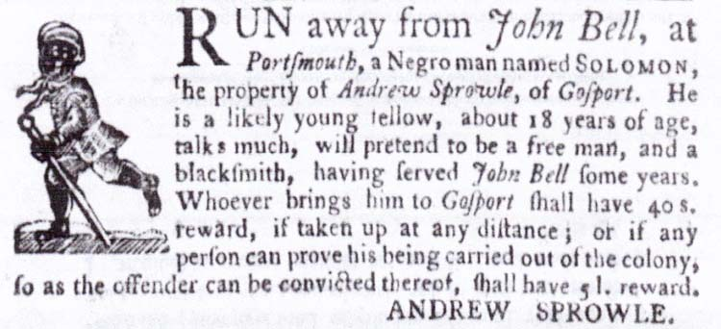  40 shilling reward for Solomon 22 Sept 1768 | 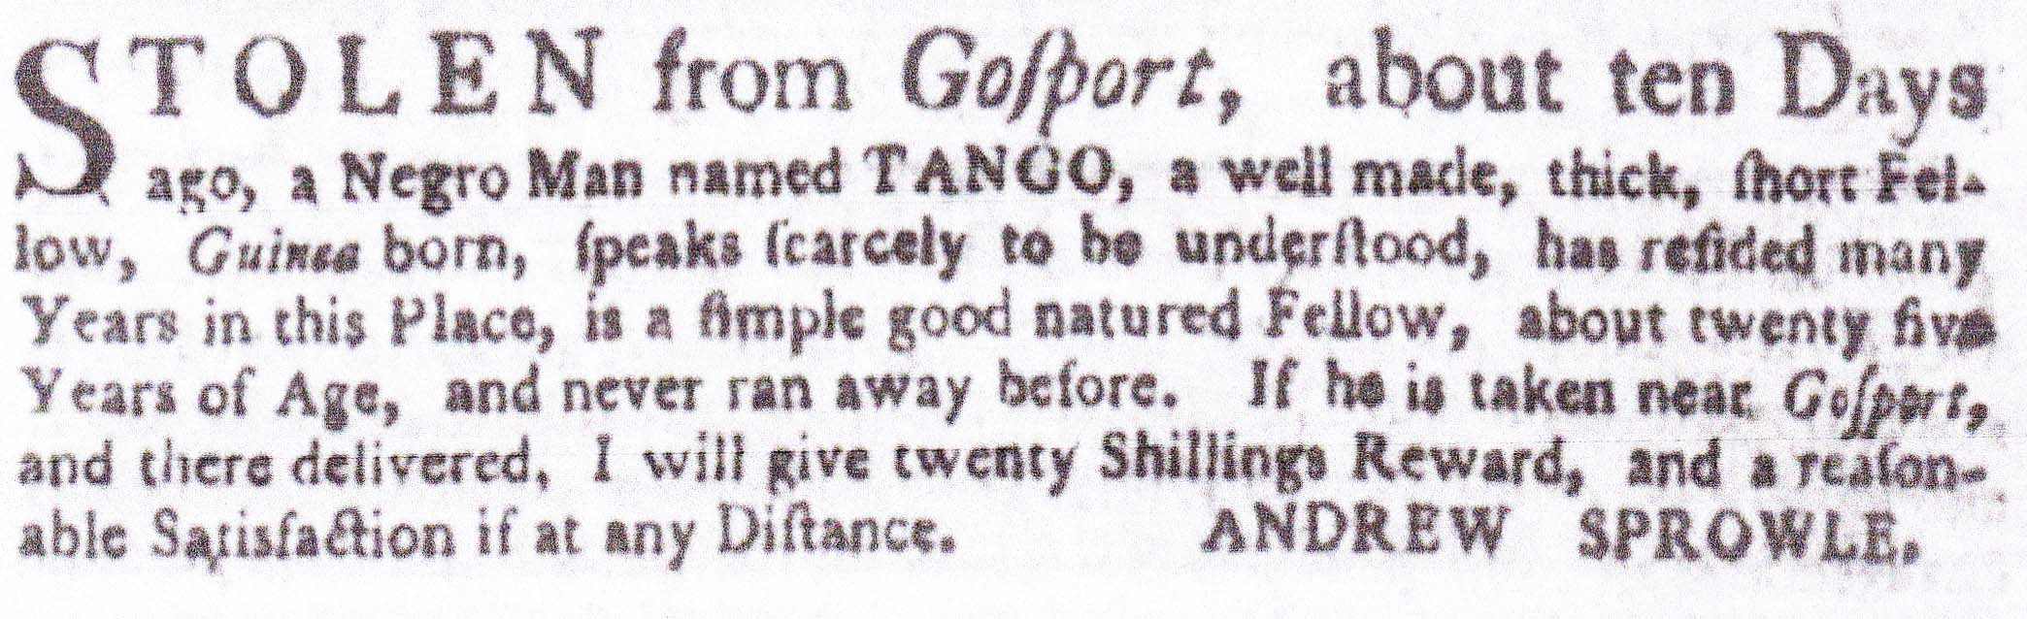  20 shilling reward for Tango, 4 Feb 1773

